**Department of Electronics and Communication Engineering**



**ShavigeMalleshwara Hills, Kumaraswamy Layout, Bengaluru – 560 078.**

**(An Autonomous Institute affiliated to VTU, Approved by AICTE )**

|  |  |
| --- | --- |
| Program: B.E. | Branch: ECE |
| Course: Ability Enhancement Course I | Semester : 3 |
| Course Code: 22ECL381 | Date: 24 Jan 2024 |

**A Report on**

**“Inverting summing amplifier with more than 2 inputs”**

**Submitted by**

|  |  |  |  |
| --- | --- | --- | --- |
| **Sl.No.** | **USN** | **NAME** | **MARKS** |
|  |  |  |  |
| **1** | 1DS22EC236 | Tejaswi MN |  |
| **2** | 1DS22EC235 | Tejas R |  |

Faculty In-charge

Dr. Chaitra A

Dr. Lavanya

**Signature of Faculty In-charge**

**Experiment: Inverting summing amplifier with more than 2 inputs using operational amplifiers**

**Aim of the experiment:** To design and simulate an inverting summing amplifier with more than two inputs using operational amplifiers (op-amps) to achieve a specified output voltage based on the sum of the input voltages.

**Circuit Diagram:**

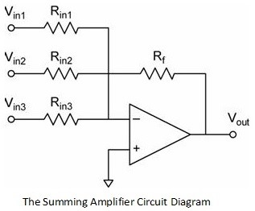

**Theory:**An operational amplifier, or op-amp, is a versatile electronic component commonly used in analog circuits for signal processing. It typically has two inputs (inverting and non-inverting) and an output. The inverting input, when connected with certain configurations, allows for the creation of an inverting amplifier. In an inverting configuration, the output signal is an inverted or opposite polarity version of the input signal.

Now, when multiple input signals need to be combined, an inverting summing amplifier can be employed. This circuit utilizes the inverting configuration of the op-amp to produce an output that is the inverted sum of the weighted input voltages. Each input is associated with a resistor, and the sum is created by adjusting the values of these resistors to achieve the desired weighted summing effect. This setup is commonly utilized in applications such as audio mixers and other scenarios, where combining and adjusting multiple input signals is necessary for signal processing and control. Careful consideration of resistor values is crucial to ensure proper functionality and precision in the summing amplifier circuit. We use the following formulae for this experiment.

$$I_{F}=I_{1}+I_{2}+I_{3}=-\left[\frac{V_{1}}{R_{in}}+\frac{V_{2}}{R_{in}}+\frac{V_{3}}{R_{in}}\right]$$

$$Inverting Equation: V_{out}=-\frac{R_{F}}{R_{in}}×V_{in}$$

$$then, -V_{out}=\frac{R_{F}}{R_{in}}\left(V_{1}+V_{2}+V_{3}+…etc\right)$$

**Procedure:**

1. Open Multisim and place an operational amplifier (op-amp) on the workspace.
2. Add resistors (R) for each input and a feedback resistor (Rf), connecting them accordingly.
3. Set resistor values based on desired gain and weighting.
4. Place voltage sources (V) for each input and connect them to the summing node.
5. Configure simulation settings and run the simulation to observe the output.
6. Analyze results, adjusting resistor values or input voltages if needed.
7. Fine-tune the design and save your Multisim file for future reference.

**Graph:**

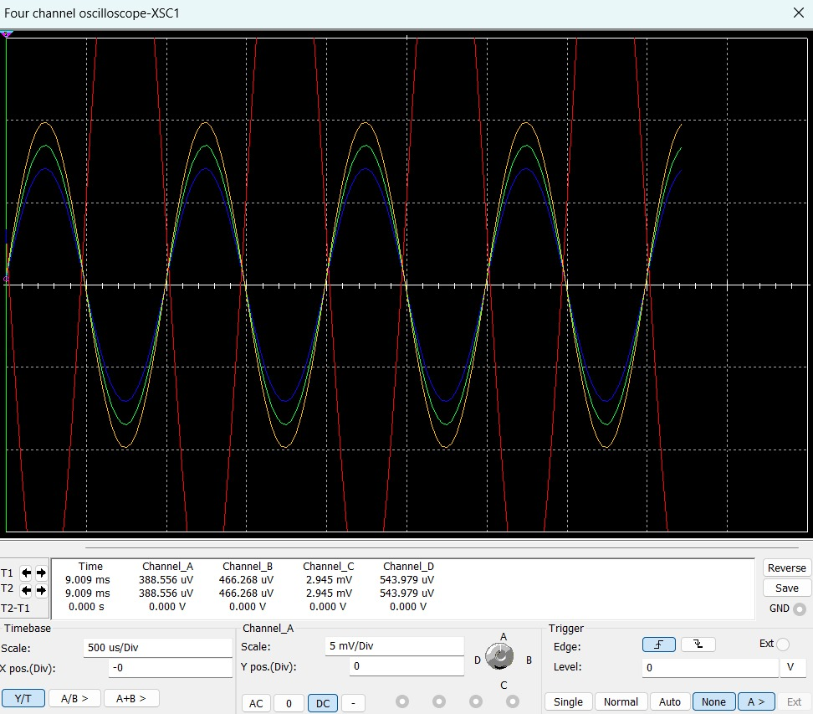

**Screenshots:**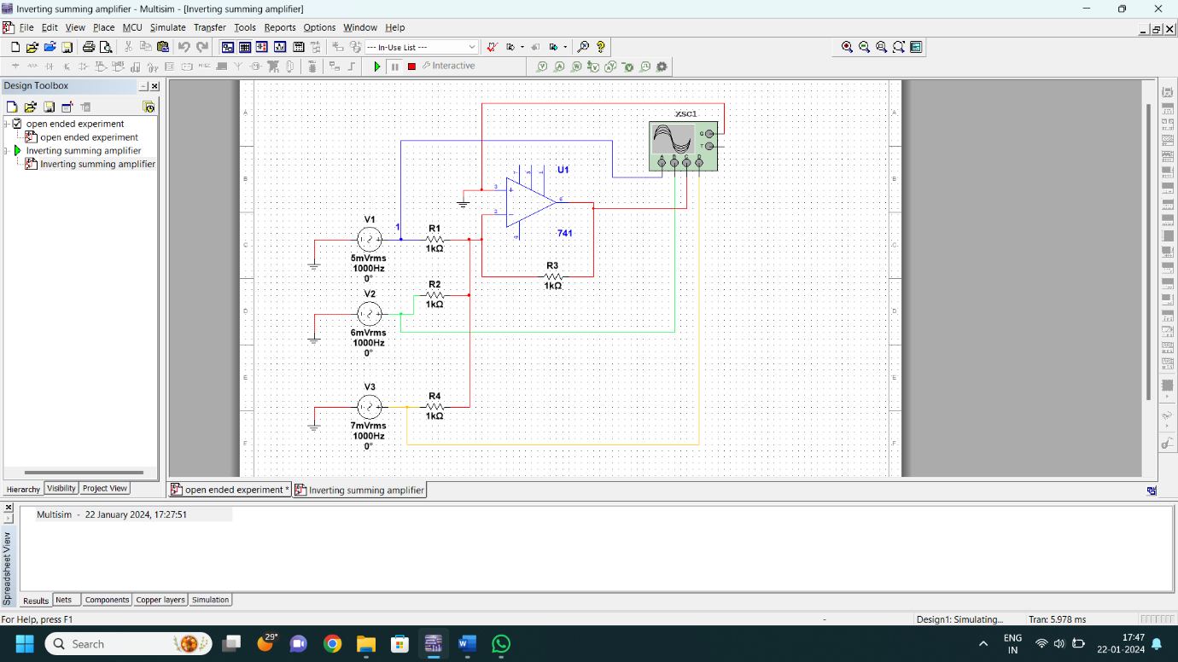

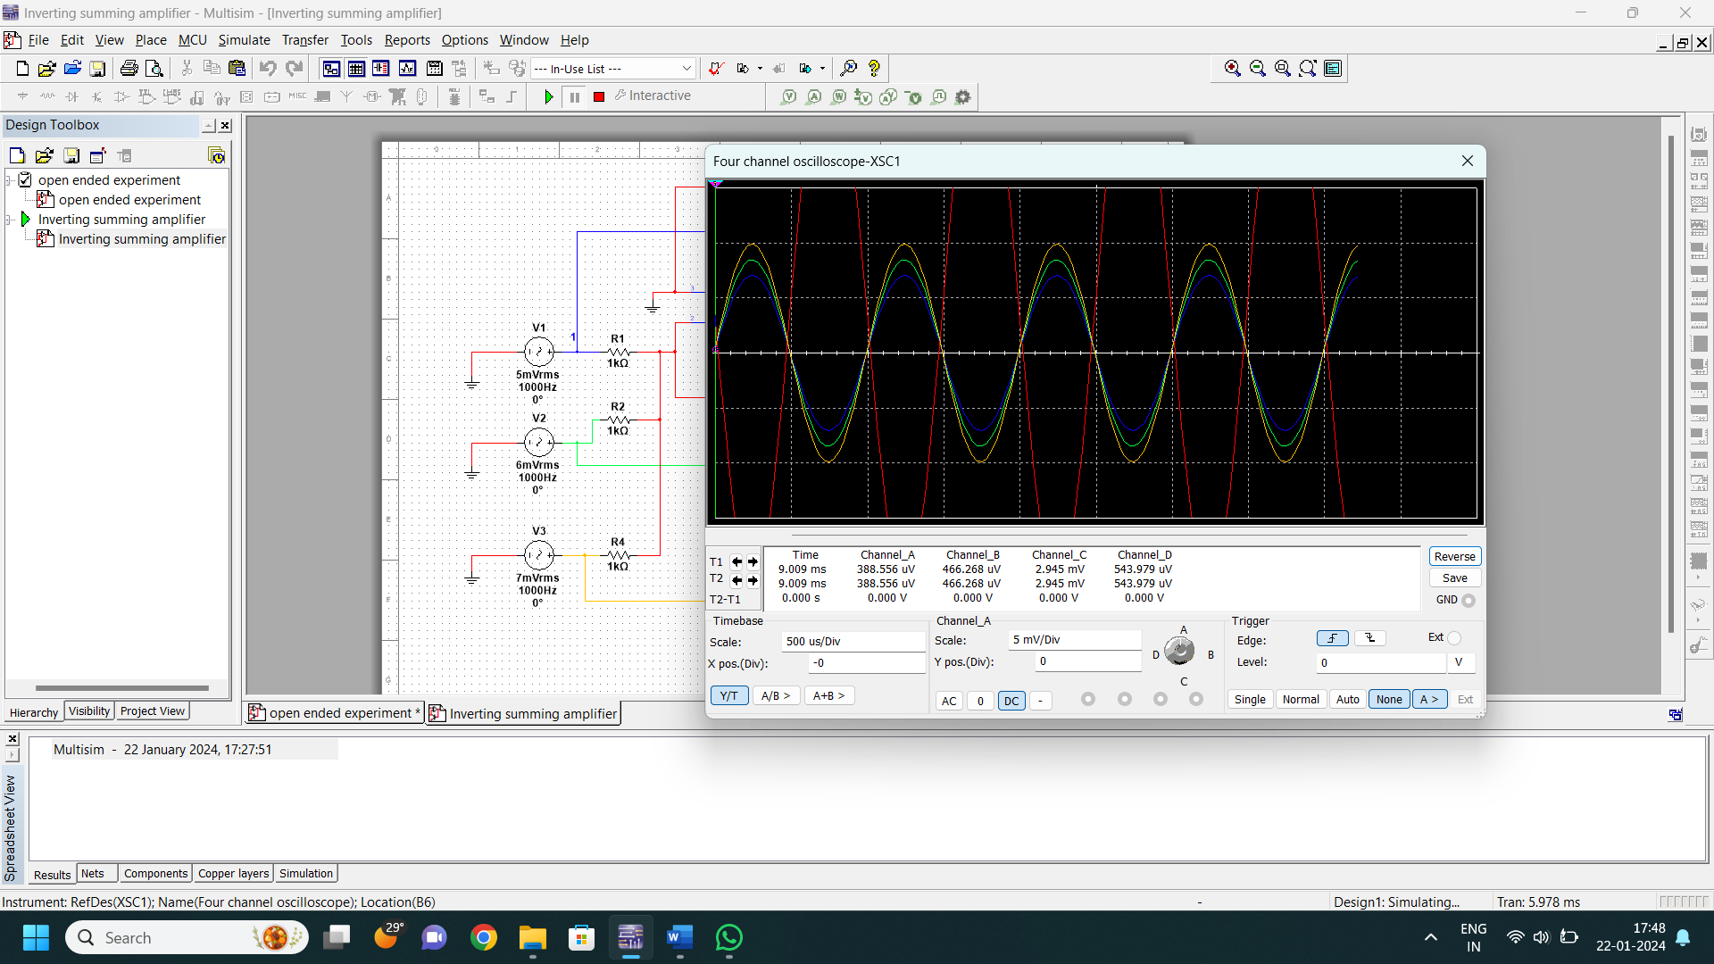

**Conclusion:**

In summary, the inverting summing amplifier with multiple inputs is a versatile circuit for combining and processing various input voltages. Its negative feedback design and adjustable resistor values make it a valuable component in electronic systems, allowing for precise customization to meet specific circuit requirements. This amplifier serves as a fundamental building block in signal processing applications, offering flexibility and precision in diverse electronic designs.